NOTES 1
THE AUDITING ENVIRONMENT

Auditing is needed to almost all aspects of our life, because of the potential occurrence of errors, fraud, or departure from the standards or targeted objectives. For the case of financial statements audit, it is needed because there are potential errors or frauds in the presentation of financial statements.

Reports/Activities | Potenstial Problem | AUDIT  FOR THESE  REASONS
Financial Statements | Error
 | Fraud
 | Departure from standards
 | Not conform with reported fact (assets, liabilities, revenues, and expenses)
 | Not disclosed sufficiently
Operational activities | Fail to meet the targeted result.
Peforming duties | Not conform with policies and procedures
Etc

THE PROCESS OF FINANCIAL STATEMENTS

Accounting
Records
Fiancial
Statements

Source
Documents
Business
Activitises

Audit to check the
existent of transactions

Audit to check the
Completeness of reporting

Notes: there are potential errors and or fraud in the presentation of financial statements

THE DEFINITION OF AUDITING

A systematic process of objectively obtaining and evaluating evidences regarding assertions about economic actions or events to ascertain the degree of correspondence between those assertions and established criteria and communicating the results to the interested users.

The attributes of the definition:
- A systematic process
- Objectively obtaining and evaluating evidence
- Assertions about economic actions and events
- Degree of correspondence
- Established criteria
- Communicating the results
- Interested users.

THE TYPE OF AUDITS

- Financial Statements Audit
- Compliance Audit
- Operational Audit
- Information Technology Audit
- Internal Audit
- Special Investigation
- Forensic Audit etc.

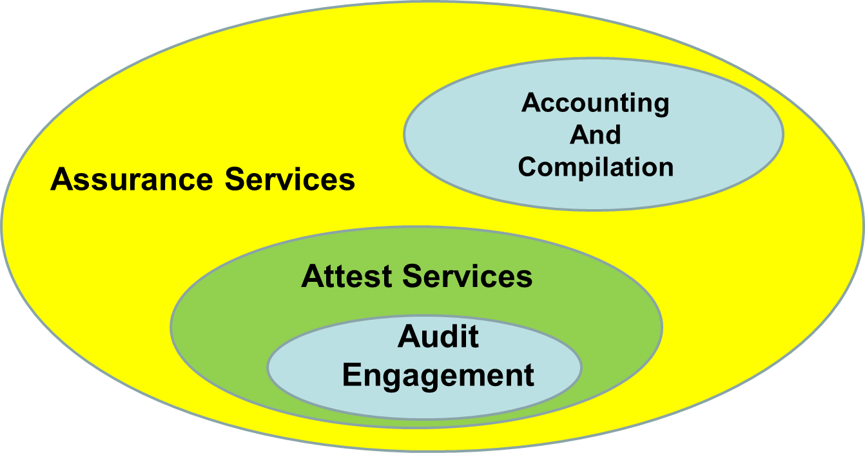
See figure 1-2 Comparative Summary of Types of Audits
Modern Auditing Page 7.

THE TYPE OF AUDITORS

- Independent Auditors
- Internal Auditors
- Government Auditors

ASSURANCE SERVICES

Definition
Assurance service is a broader term that includes audits and a variety of other assurances about various representations of management. Definition according to AICPA: Assurance services are independent professional services that improve the quality of information, or its context, for decision makers.

See Universe of Assurance Service figure 1-3 modern auditing page 13

Example of Assurance Services
- Audit Engagements
- Attest Services
- Accounting and Compilation Services.

VALUE OF AUDIT AND ASSURANCE SERVICES

- Capturing business events in the form of data
- Communicating the total picture with integrity and objectivity
- Transforming complex information into knowledge
- Anticipating and creating opportunities.
- Decision making.

THE NEED OF FINANCIAL STATEMENT AUDITS

- Conflict of interest
- Consequence
- Complexity
- Remoteness

ECONOMIC BENEFITS OF AN AUDIT

- Access to capital markets.
- Lower cost of capital.
- Deterrent to inefficiency and fraud.
- Control and operational improvements.

LIMITATION OF AN AUDIT

- Reasonable cost
- Reasonable length of time
- Alternative accounting principles or methods
- Accounting estimates.

******

